

**Assignment 01**

**Name: Sadaf Riaz**

**Roll No: 2023-BSE-077**

**Subject: Cloud Computing**

**Class: BSE5-B**

**Instructor: Sir Waqas**

**Due Date: 19 October 2025**

**Task 1**

**Run Gitea in Codespace**

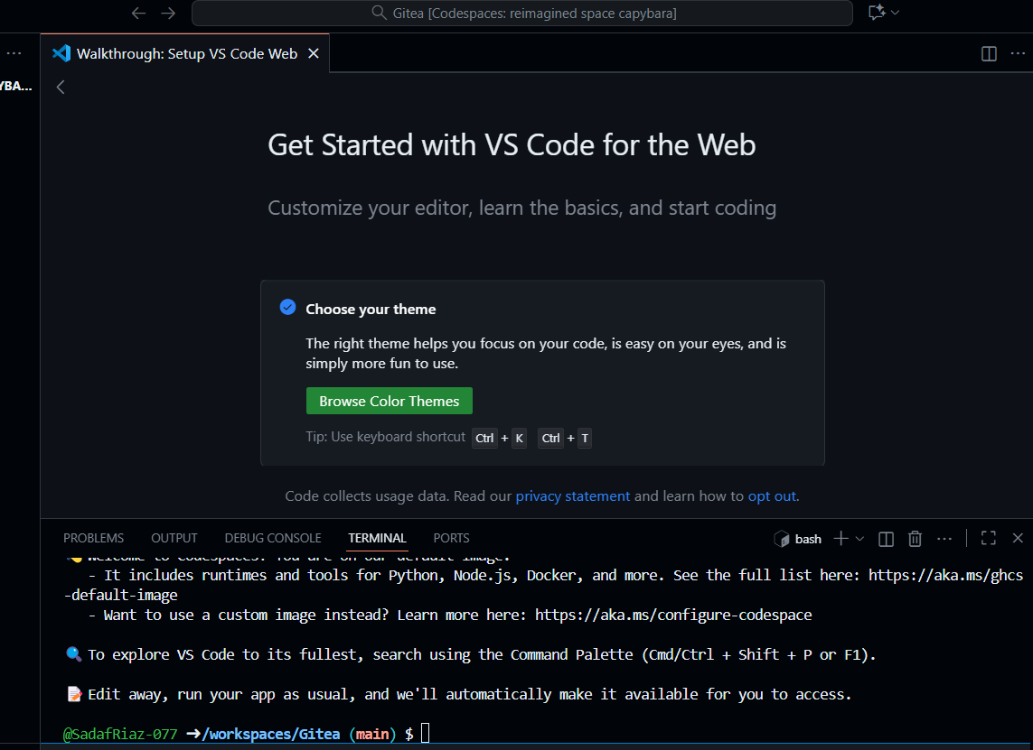

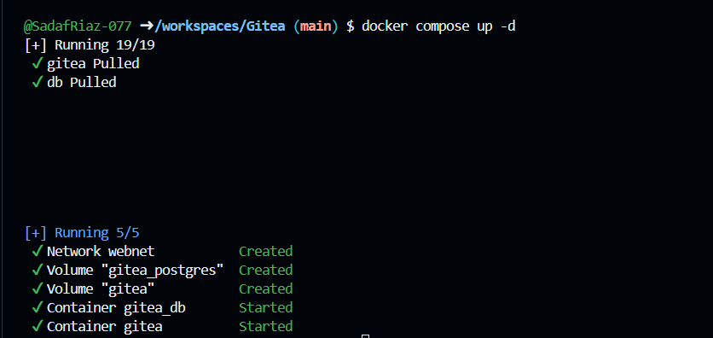

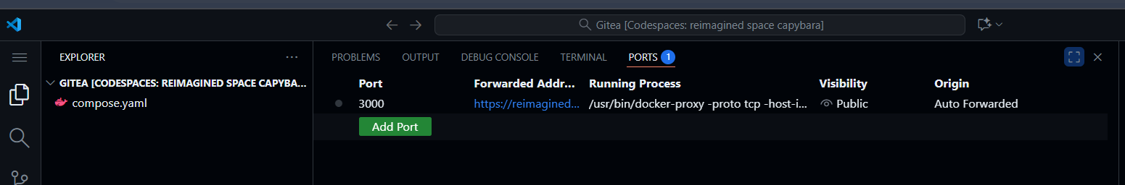

**Installation**

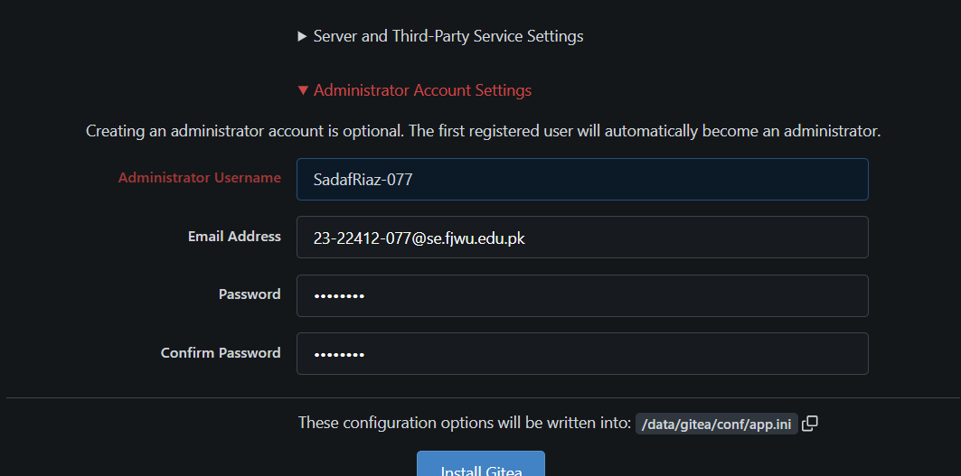

**Dashboard**

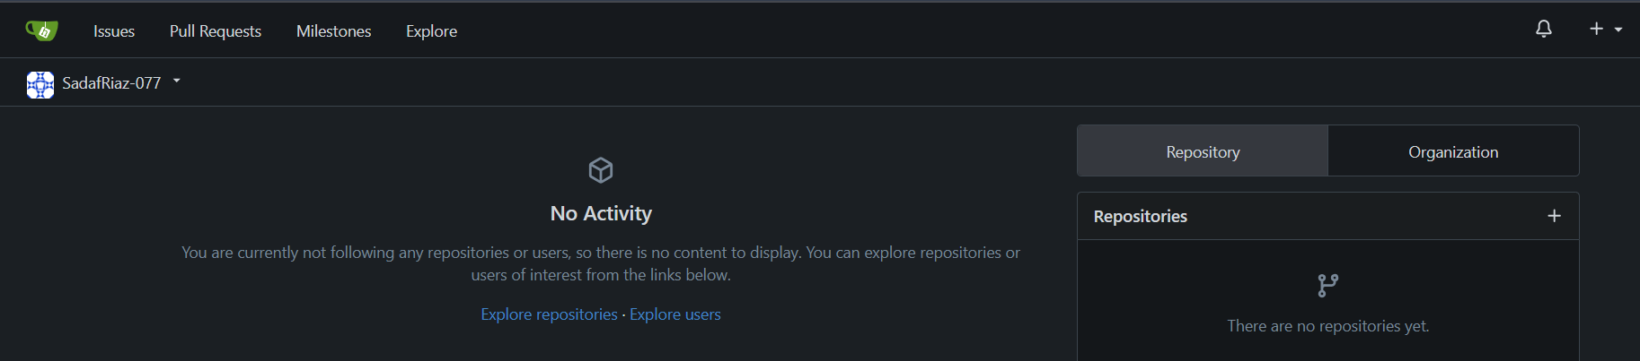

**Create New Repository in Gitea**

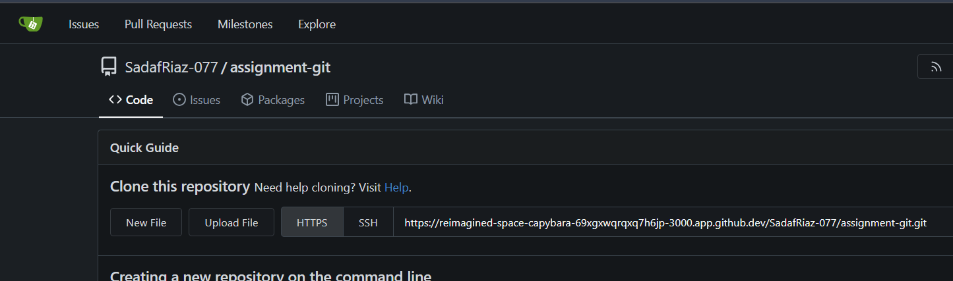

**Create and Push README.md to Repository**

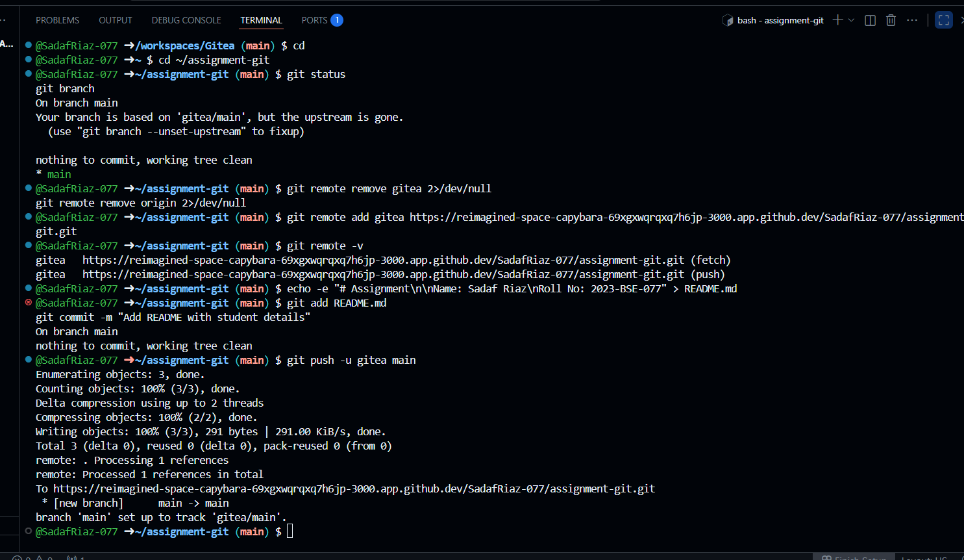

**Screenshot of your Gitea repository (showing README listing name & roll numbers)**

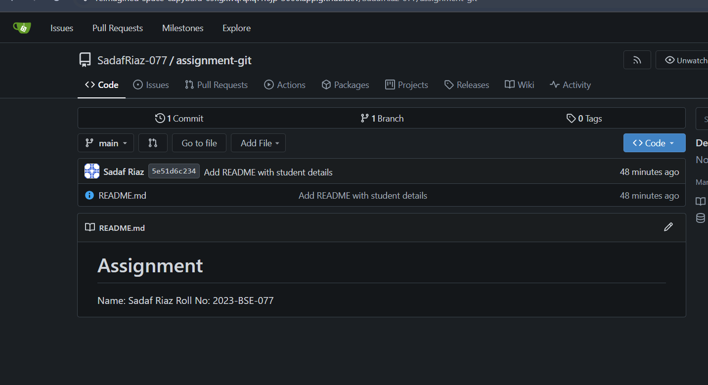

**Task 2**

**Create GitHub Repository:**

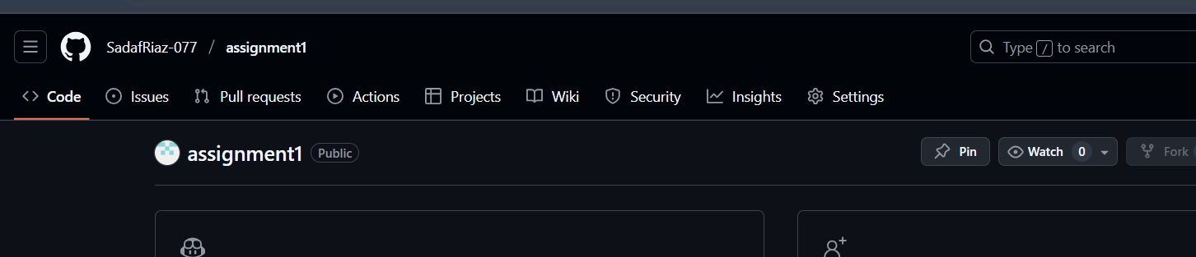

**Mirror README.md from Gitea to GitHuba and Remmote Verification:**

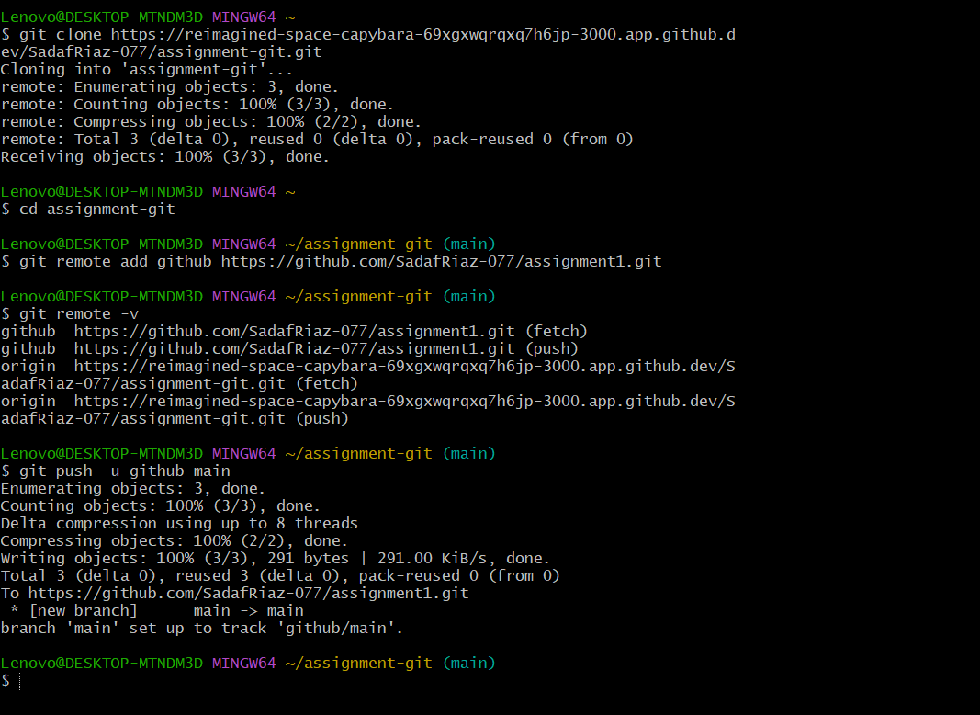

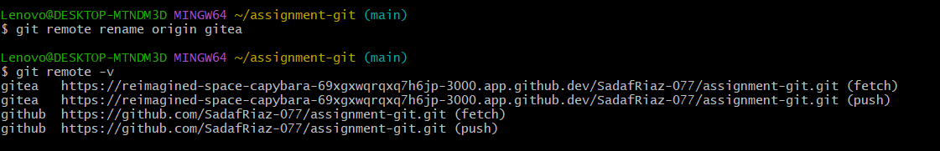

**Screenshot or output of git remote -v showing both remotes**

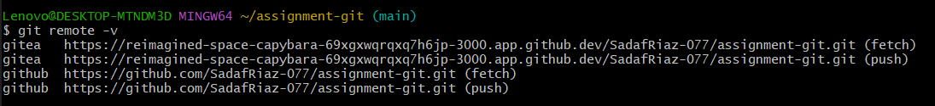

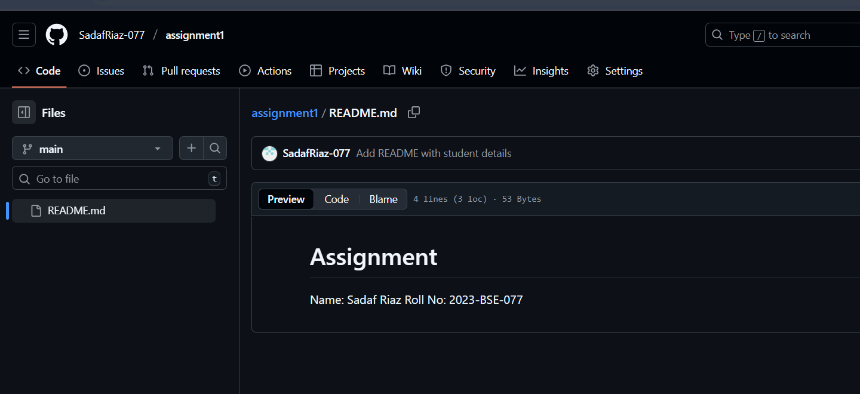

**Task 3**

**Add Large Files Using Git LFS**

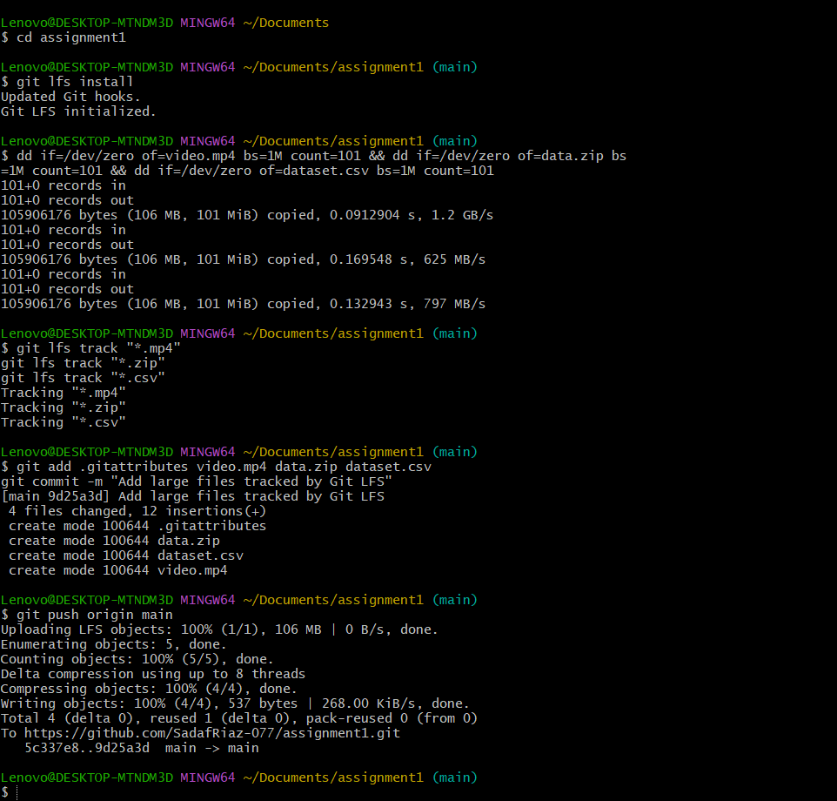

**GitHub repo showing LFS pointer lines (files)**

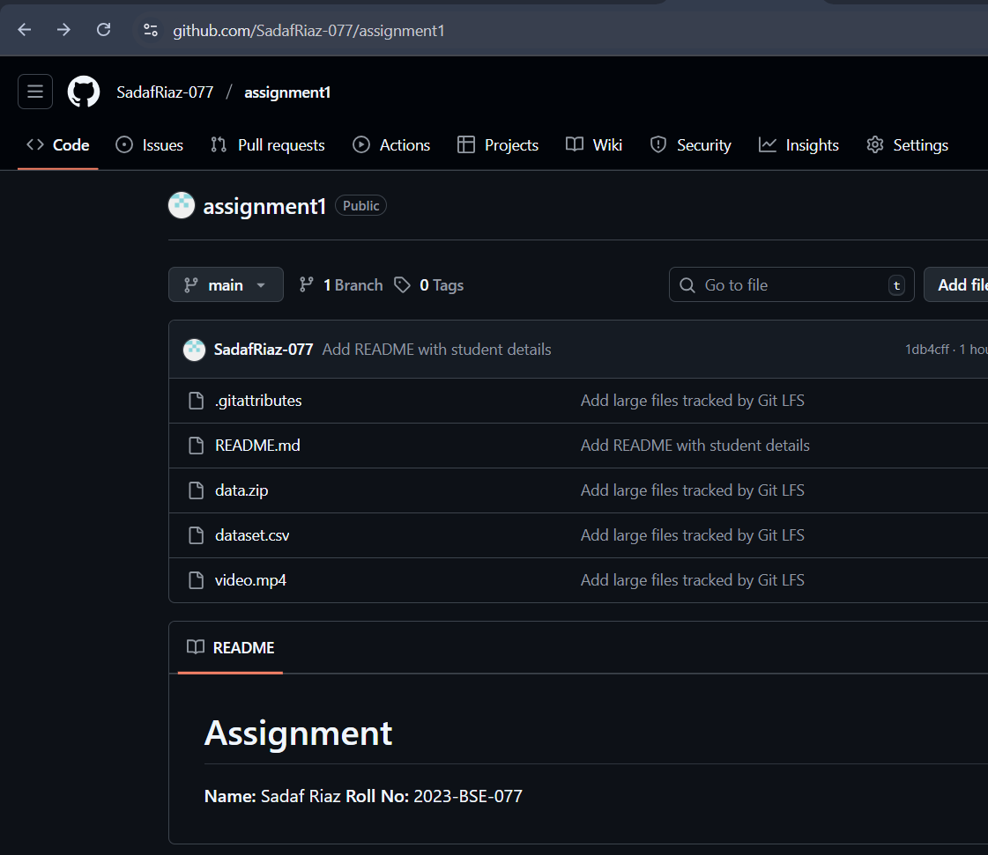**GitHub assignment1 repo link (with README and large files**)

link :https://github.com/SadafRiaz-077/assignment1

**Task 4**

**Create a New GitHub Repository**

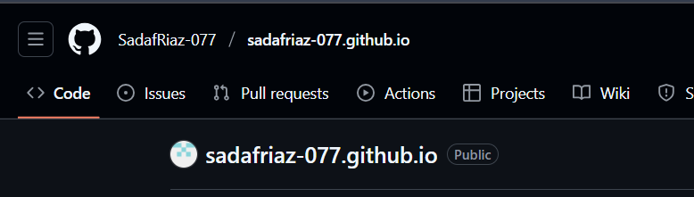

**Prepare CV**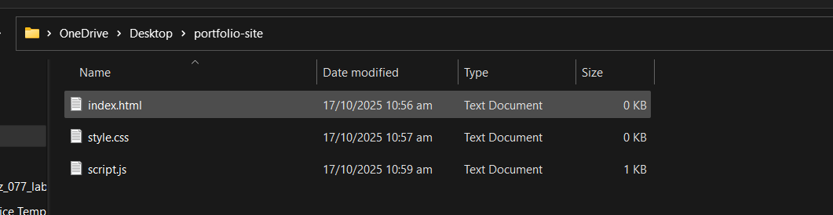

**Upload Files to the Repository**

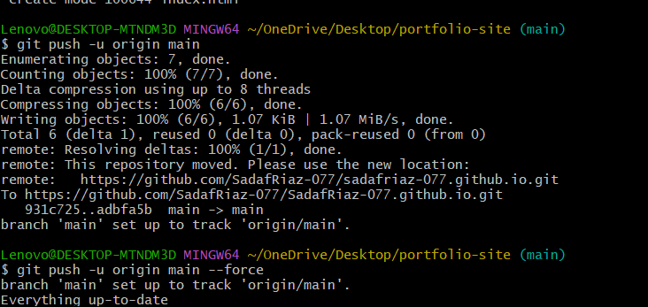

**Enable GitHub Pages**

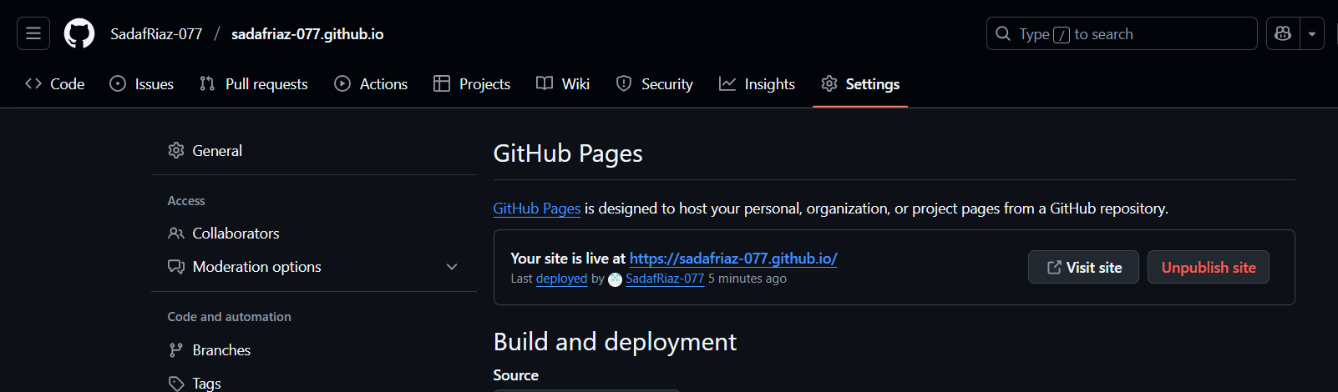

**Test and Verify**

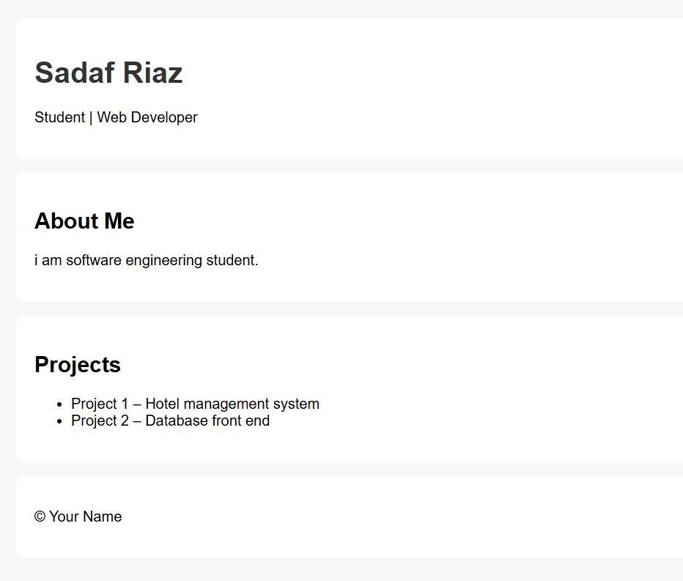**GitHub Pages link to CV**

link : https://SadafRiaz-077.github.io